Networking
Module 3&4 Assignment :
Questions :
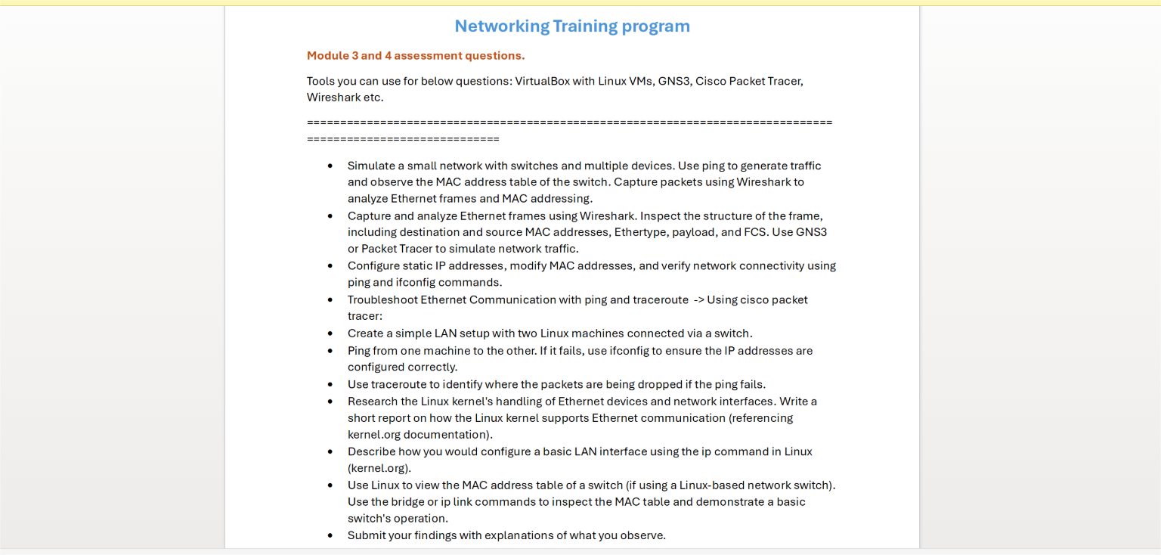

Answers :
1.
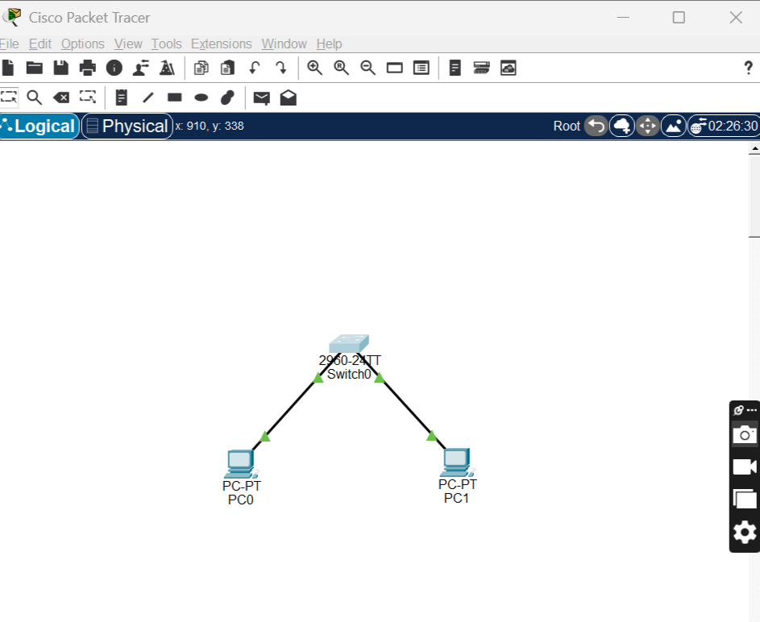
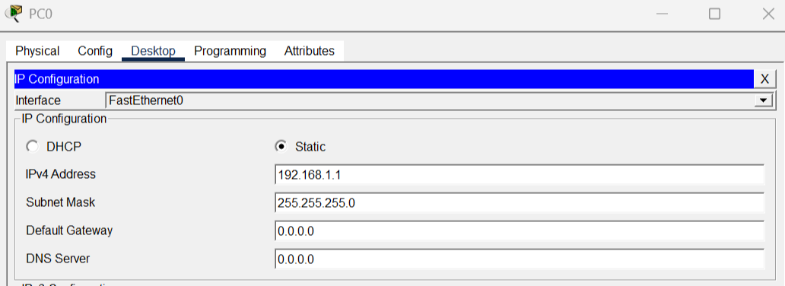
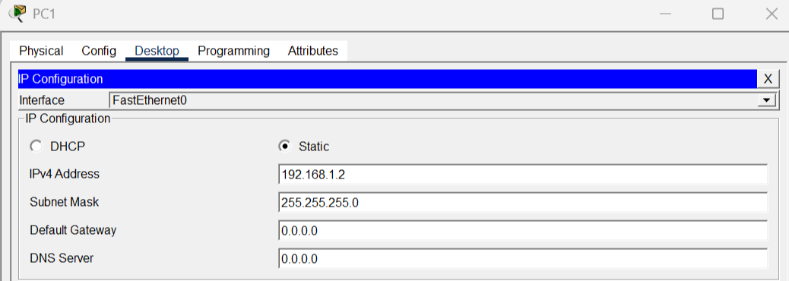
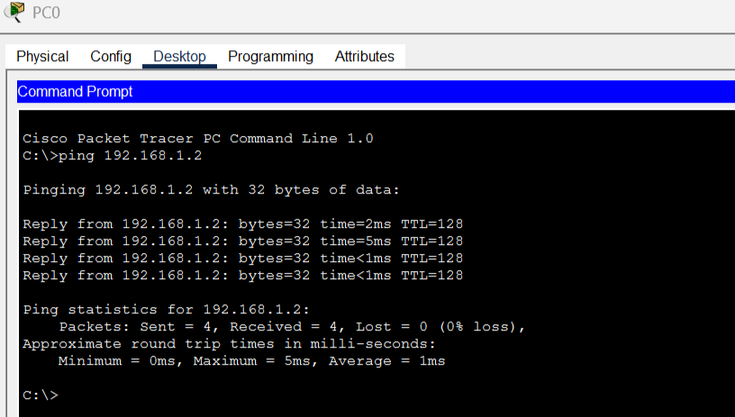
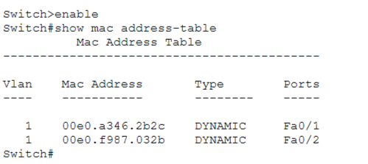
Steps :
- PC0 sends data → switch doesn’t know destination
- Switch broadcasts
- PC1 replies
- Switch learns:
MAC of PC0 → Fa0/1
MAC of PC1 → Fa0/2

2.

Destination MAC - Receiver device address

Source MAC - Sender device address

Type (EtherType)
What protocol is inside:
- IPv4 → 0x0800
- ARP → 0x0806

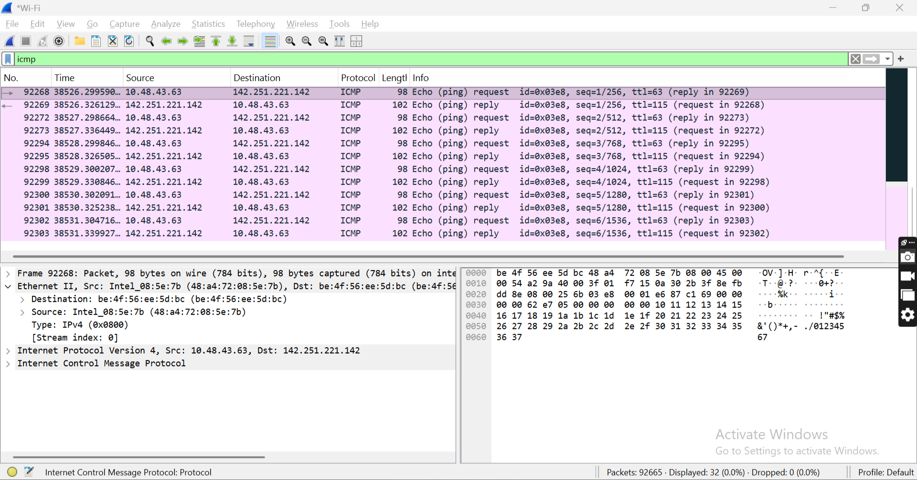

3.
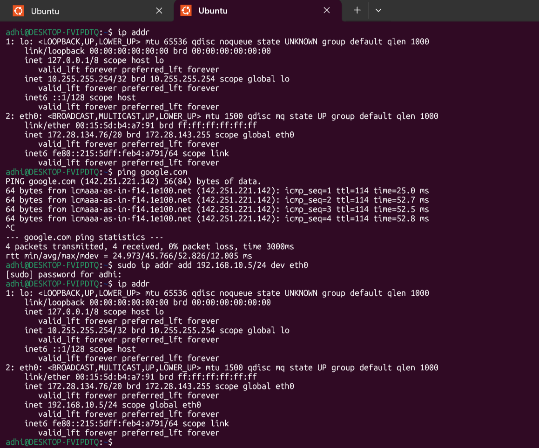
4. Note : MAC address modification is temporary and resets after reboot.
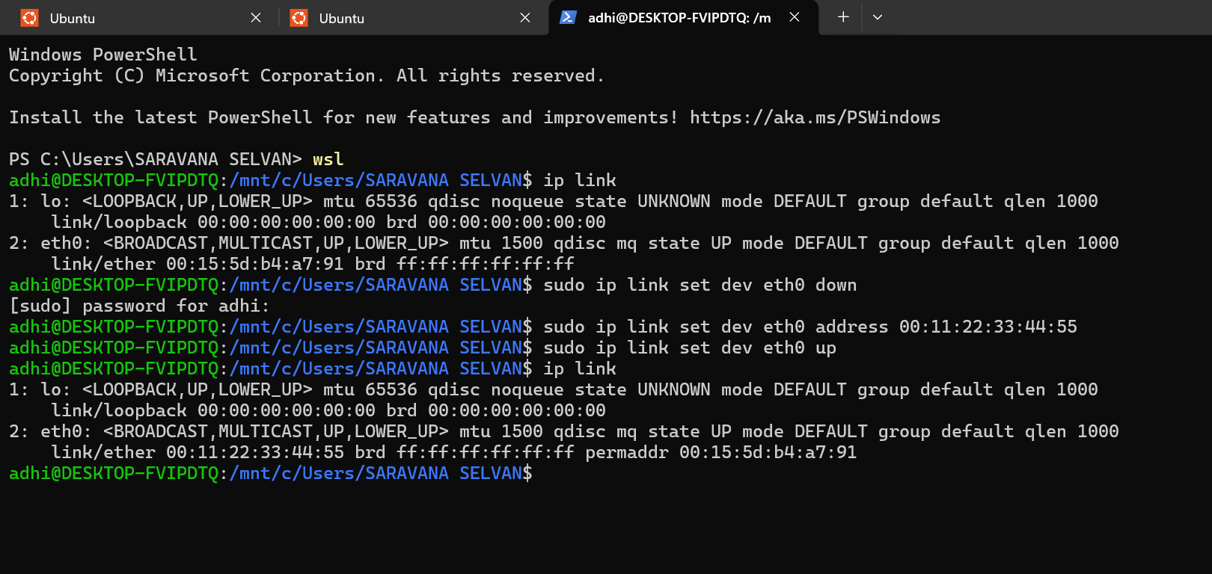
5.
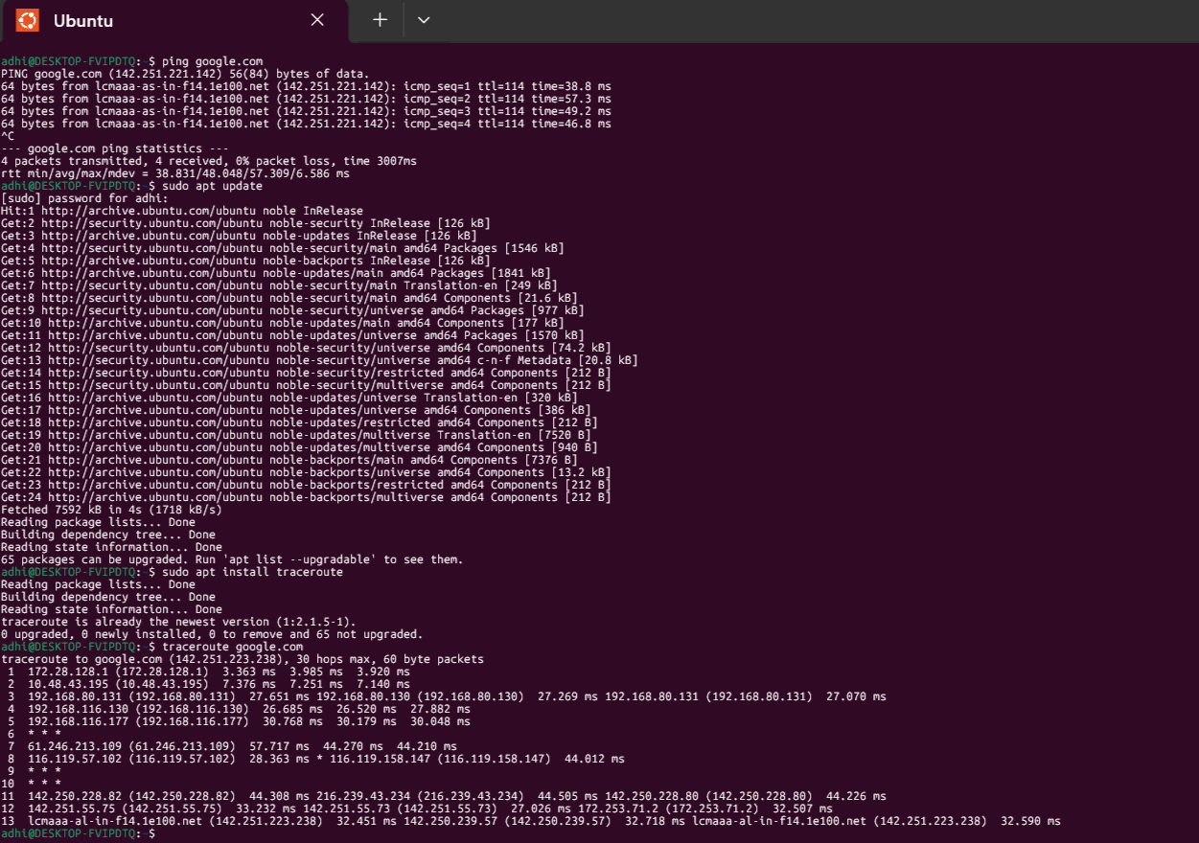
6.





Steps :
- PC0 sends data → switch doesn’t know destination
- Switch broadcasts
- PC1 replies
- Switch learns:
MAC of PC0 → Fa0/1
MAC of PC1 → Fa0/2

7.

8. Linux kernel handles Ethernet communication using a layered network stack.
Data flows through the following layers:
- Application Layer
- Transport Layer (TCP/UDP)
- Network Layer (IP)
- Data Link Layer (Ethernet)
- Physical Layer
The kernel uses network interface drivers to interact with hardware devices like Ethernet cards.
The Data Link layer adds MAC addresses and creates Ethernet frames, while the Network layer handles IP addressing and routing.
The Linux kernel also manages packet transmission, reception, and routing through its networking subsystem.
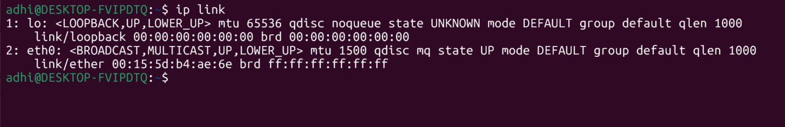
“What does Linux kernel do in networking?”
Answer:
- Handles packet flow
- Manages routing
- Controls network interfaces
9.
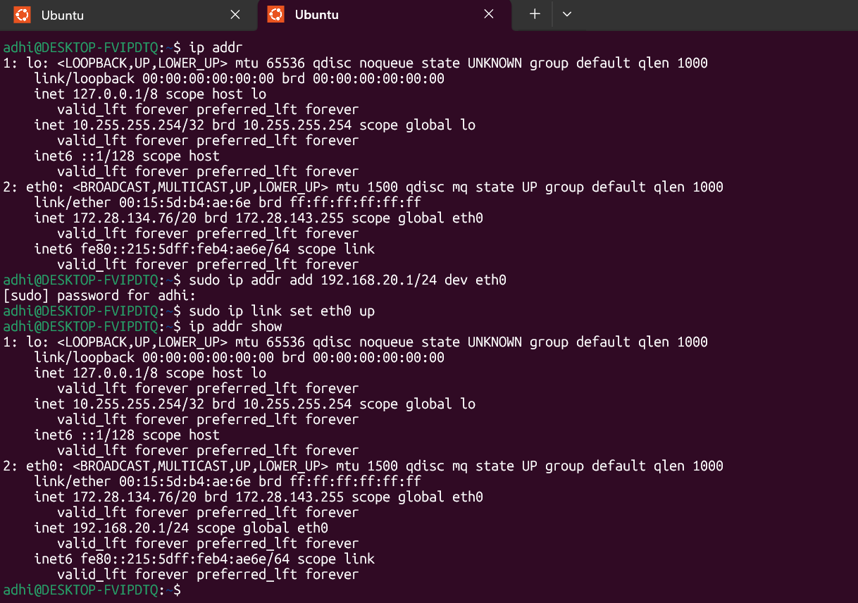
What Happened
- You manually assigned IP
- Interface is now configured
- System can use this IP for communication
Important Note (WSL)
In Windows Subsystem for Linux:
- Changes may be temporary
- May not behave like real Linux
- But still valid for assignment

10. How It Works Internally
- Device sends frame
- Bridge learns MAC
- Stores:
MAC → Interface
- Uses this to forward frames

